
Shotteswell Parish Council
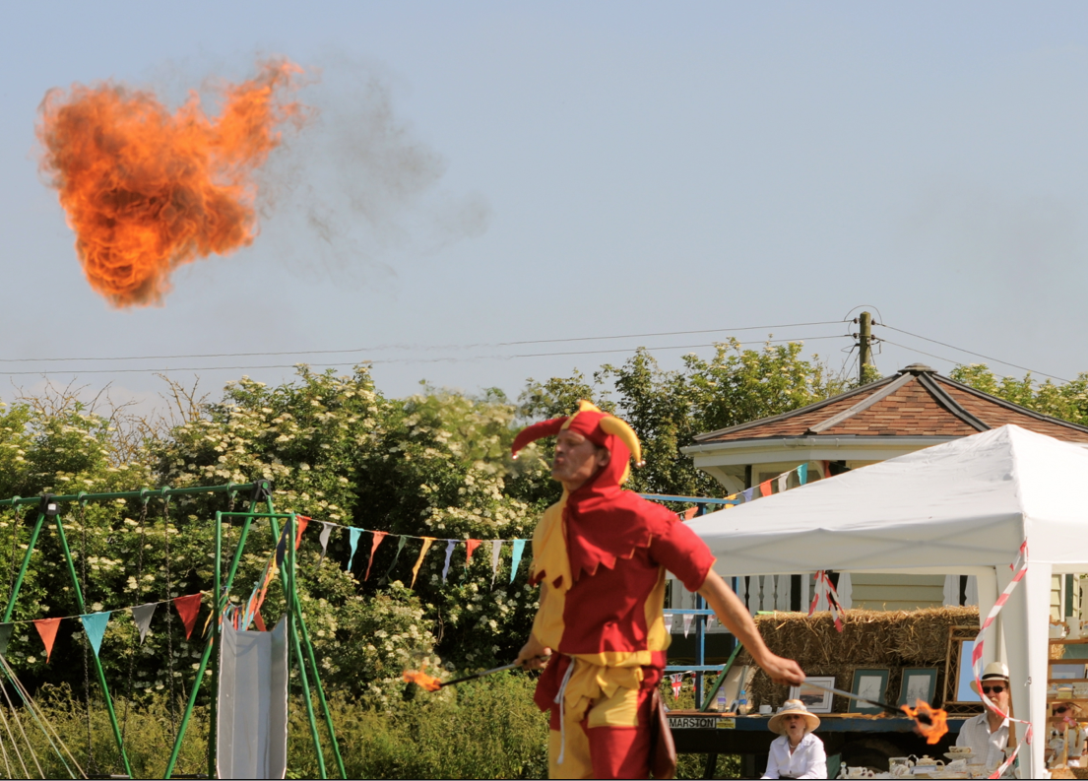
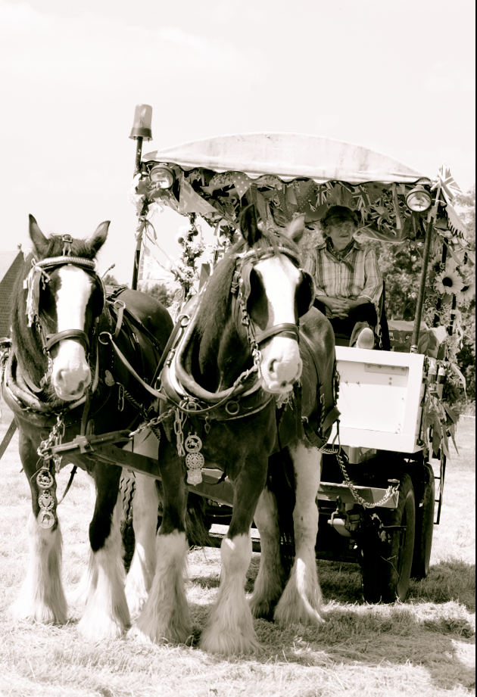
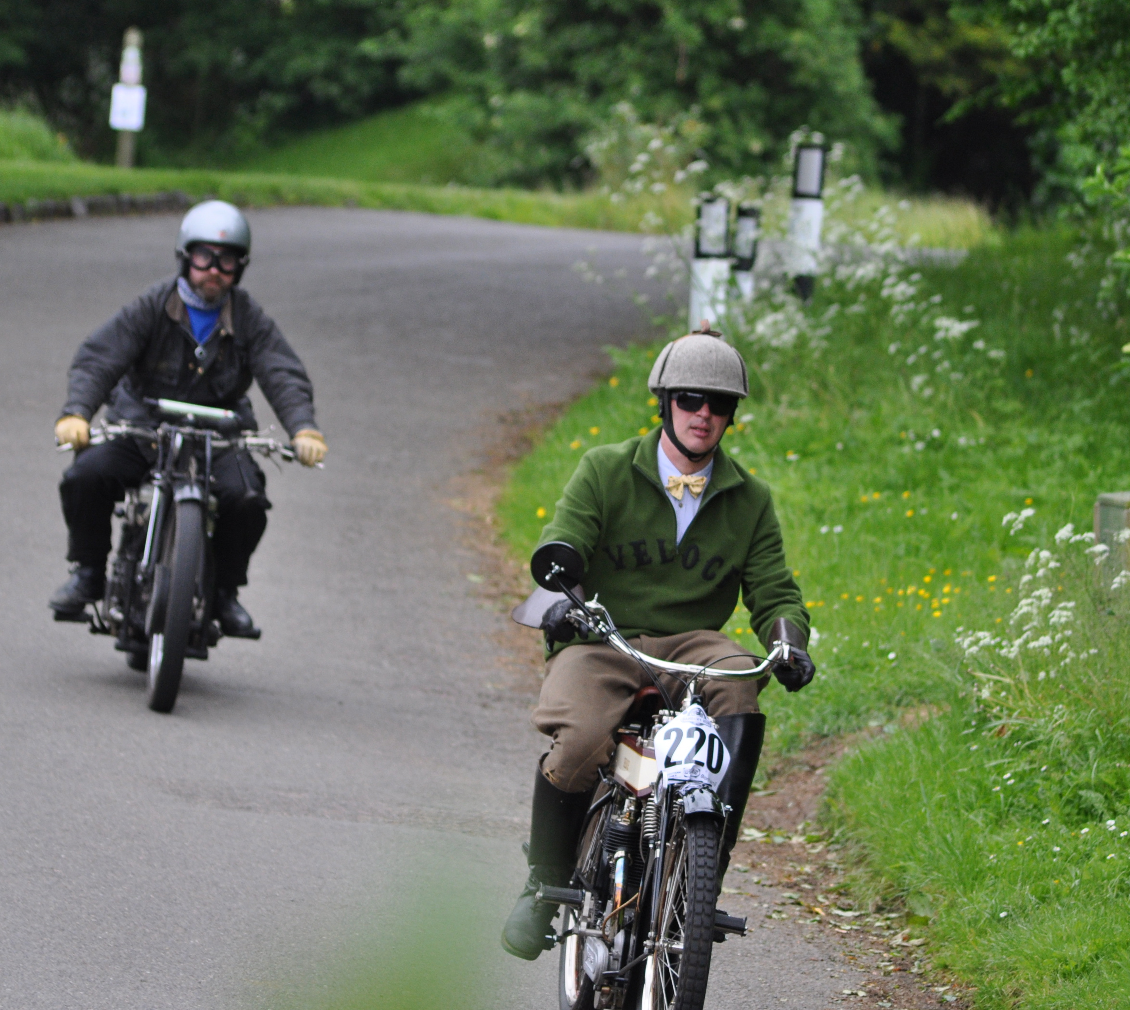

Chairman’s Annual Report 2014
A year in review:-

Firstly, on behalf of the Parish Council a warm welcome to all new residents and thank you to existing residents for their continued support in keeping Shotteswell a nice place to live.
We warmly welcomed Cllr George Nell onto the Parish Council, following an uncontested election last May.

Refuse
Stratford District Council is amongst the top ten in the country (247 councils) for recycling rates, I am sure you will agree this is an admirable achievement. Cllr Simon Jackson, (SDC) recently asked for his thanks to be conveyed to residents for their sterling work in helping to achieve this placement.
Set out below for your convenience is the refuse collection dates calendar for the year. Although Christmas collections have not yet been announced, when they are available we will post a note to the noticeboard and to the web site: www.shotteswell.village.co.uk as we did last year. (N.B Due to monochrome print, grey collections begin 5th March)
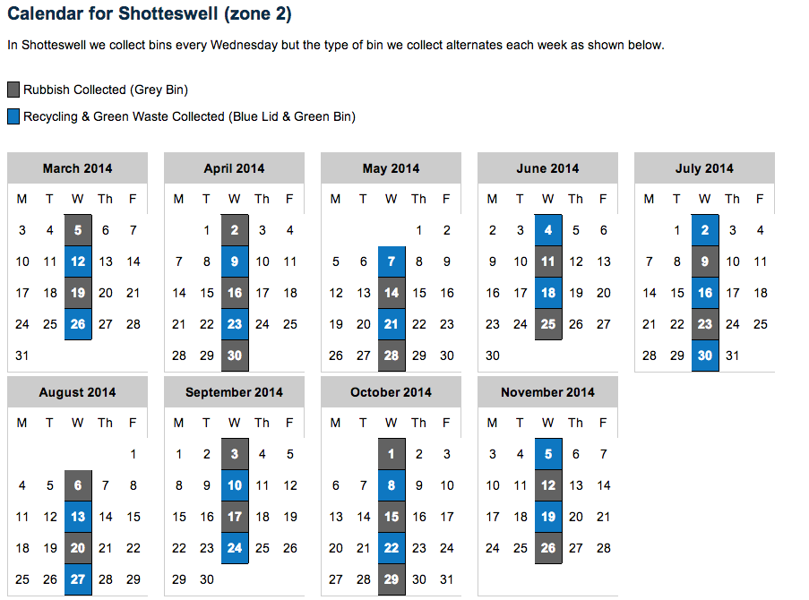
Incidents of fly tipping have reduced, but please let us know if you spot any items. Recently we were made aware of a seemingly abandoned shopping trolley on the B4100, located close to the junction of First Turn. This was found to belong to an itinerant and was left in situ for a while to allow time for the gentleman to recover his possessions, the gentleman had been taken to hospital for treatment.

Telephone Problems

Early one Saturday morning last summer we discovered that the telephone and Internet service had been severed to the village. As a result everyone encountered severe difficulties particularly in contacting emergency services. The cable had been cut through and this was found to have taken place in the Horley Road vicinity. The Parish Council promptly lobbied BT to undertaken repairs as quickly as possible, it was not generally helped by the fact that most of the calls were diverted to a Call Centre not based in the UK and proved to be very costly to make calls from mobile telephones. We asked the Resilience Team (Warwickshire County Council) to take this issue up regarding providing an easily accessible emergency number for BT. The thieves did not make off with the copper cabling, but owing to the cable being cut the whole line had to be replaced. Although great strides are being taken to counter this type of criminal activity the wire is we understand being shipped abroad rather than taken to local scrap merchants, and so despite the new legislation regarding scrap metal identification, this is causing tremendous expense for BT. After the repair to the cabling considerable work had to be undertaken at the cabinet in Shotteswell to restore individual lines.
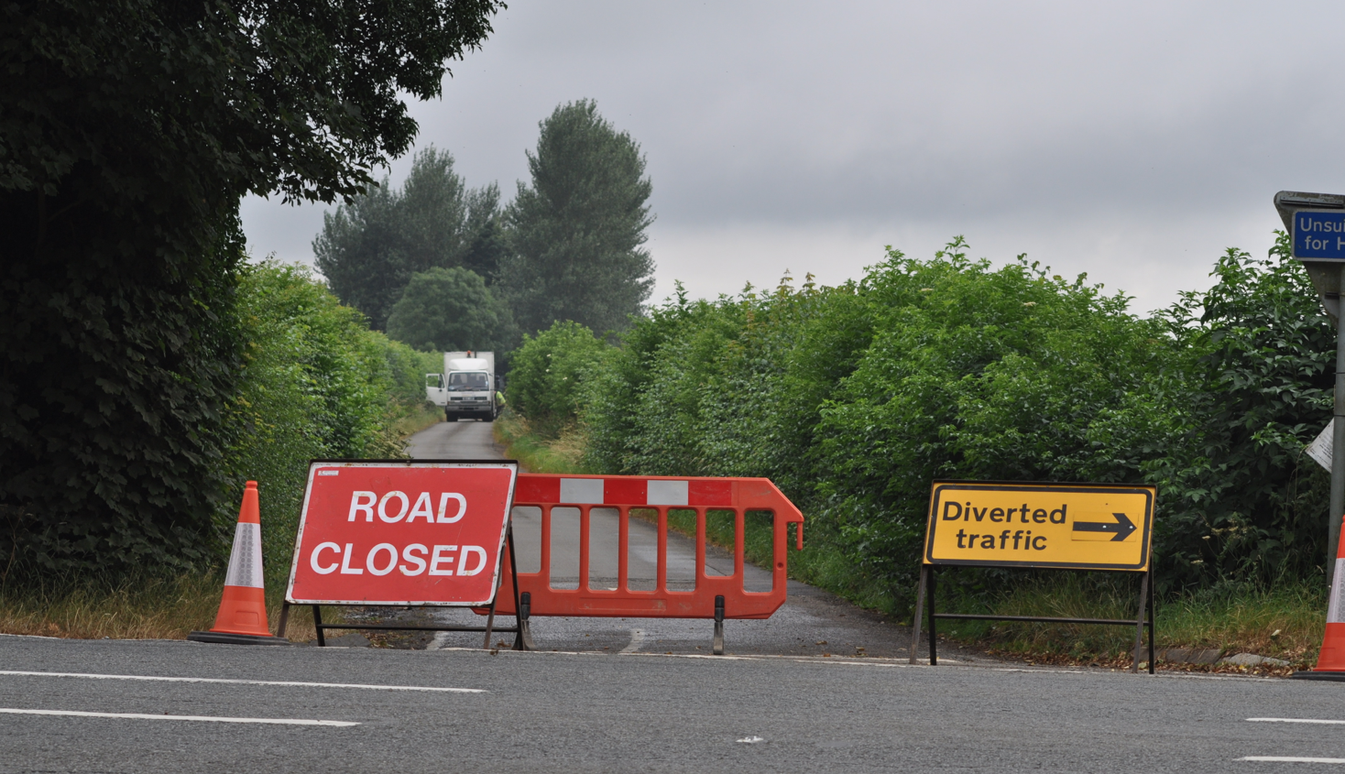
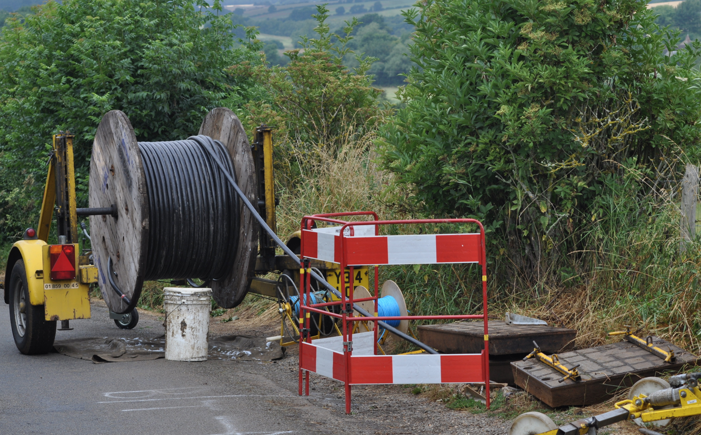
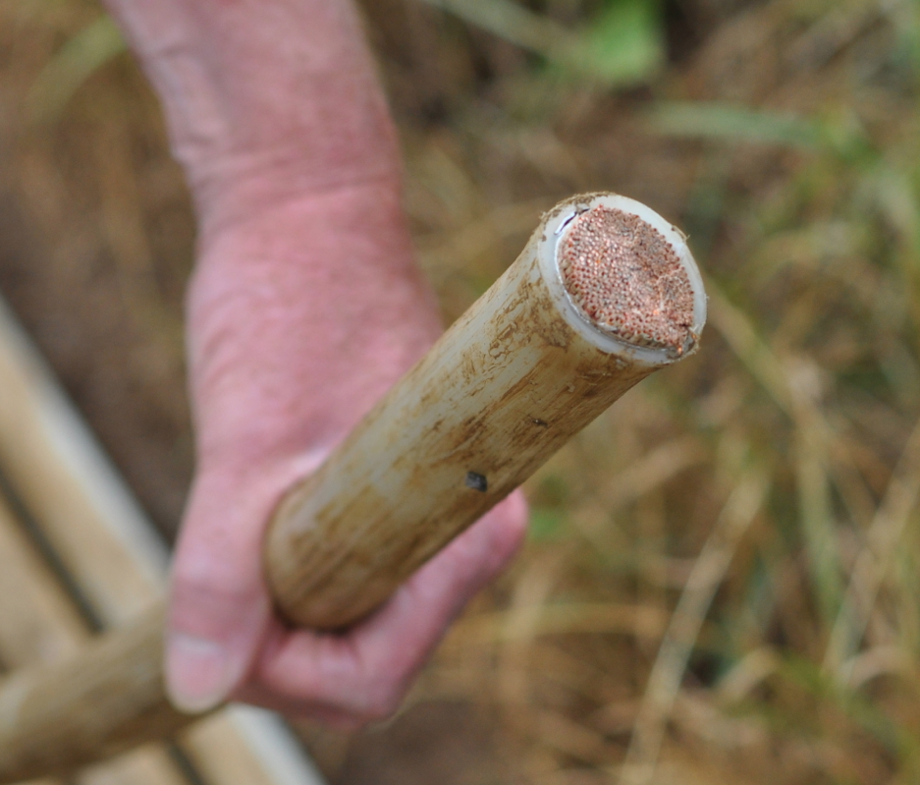
All pictures above taken at the Horley Road, and BT mending the cable.
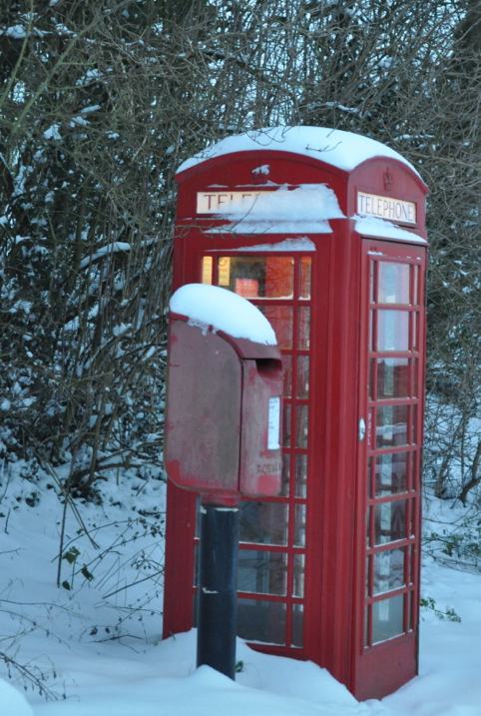
Below Shotteswells BT cabinet.
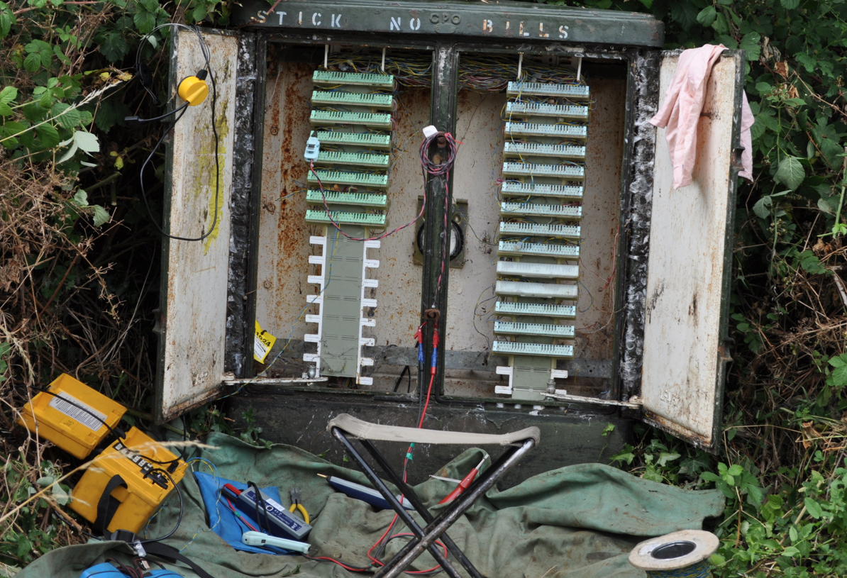
Although on this occasion even the telephone box was out of order, it has to be acknowledged that our telephone box is both valued and very useful when there is a power cut. Most people no longer have analogue telephones and even mobile phones are reliant on the electrical supply to some extent and mobile reception in Shotteswell has a tendency to be patchy throughout the village. The red telephone box is a part of our heritage and adds a distinct character to this Conservation Village, the box also doubles as a very useful navigational aid.

Defibrillator

A defibrillator(defib) or (AED), an automatic external defibrillator is a portable device about the size of a shoebox, and it is designed to give an electrical shock to restore the heart’s natural rhythm following a cardiac arrest.

The village was very fortunate to have been donated a defibrillator into the Parish Council’s safekeeping by Rosemarie Higham-Stevens . This AED is dedicated to the memory of Richard Corbett, a former resident of the parish who sadly collapsed during a Parish Council meeting after suffering from a heart attack.

Despite some residents coming forward at the time and undergoing training to use the equipment and CPR techniques initially, this proved to be unworkable mainly due to people being unable to commit to a rota, as this was considered too restrictive.
The Parish Council has undertaken considerable research into coming up with a solution to enable this life saving equipment to be made available to the community and we have decided upon a code access housing cabinet.

The Parish Council has explored, sought and have been awarded funds to help pay for the housing cabinet. The cabinet is accessed through a unique code specific to the individual cabinet and is only released to the public through a 999 emergency call. In practice this means that a 999 call is placed, the operator will tell the caller to get help and the helper would then fetch the unit. The operator will stay on the line giving advice about CPR (CPR means cardio-pulmonary resuscitation. CPR is about waking up the heart and lungs) until such times as the defib is delivered and eventually the paramedics arrive and take over.
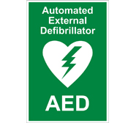
The defib itself is controlled by an inbuilt computer which gives verbal instructions of how to use the machine, and commences giving directions once the lid to the defib is lifted. No one needs to be afraid to use this machine. The gel pads, which attach to the chest of the victim, will only deliver a shock if it is necessary. Some patient’s hearts do not arrest immediately following a heart attack, but by having this machine monitoring the patient’s heart, if the heart arrests the machine is ready to deliver this life saving aid. It has to be borne in mind that ambulance response times are not always good to the village.

The Parish Council considers this to be of immense benefit to the community.
Heart attacks can happen at any age, this is why sports facilities including schools are being actively encouraged to install these machines. The ideal location for the Shotteswell Defib(AED) will be the Village Hall, as this is a public building which is accessible, has an electrical supply and somewhere everyone is familiar with. Most village activity centres around this area, with people using the hall, church or children’s playing field.

The Parish Council will meet the costs of installing the box onto the hall wall and all associated costs. The necessary administration will be the sole responsibility of the council, including the necessary insurance cover. The Parish Council will also pay for a sensor light to be installed over the hall’s double doors, delivering a two fold purpose, one to be able to locate the defib should it be required at night, secondly to improve security and to make easier access for patrons being able to lock and unlock the hall doors when dark.

It is our intention once the box is fixed to the wall to run a few First Aid sessions to enable villagers to familiarise themselves with the equipment, to learn what to do in an emergency and some basic first aid. A letter will go out to residents as soon as we have agreement to the installation. Watch for further news.

World War One Centenary
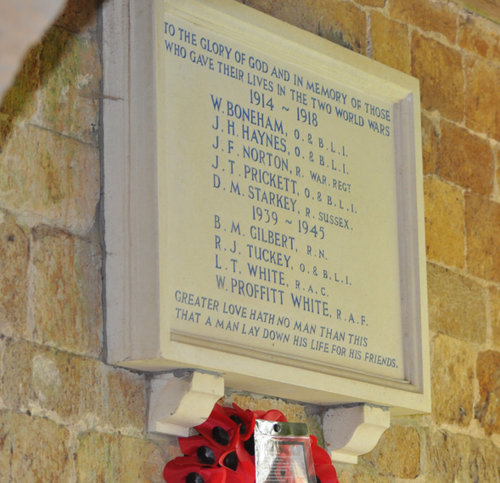
It is our intention to plant some poppies in the verges to commemorate the First World War Centenary, in line with many other communities across the country. This parish lost five men between 1914 -1918. They gave their lives for the country and this is to honour their sacrifice.


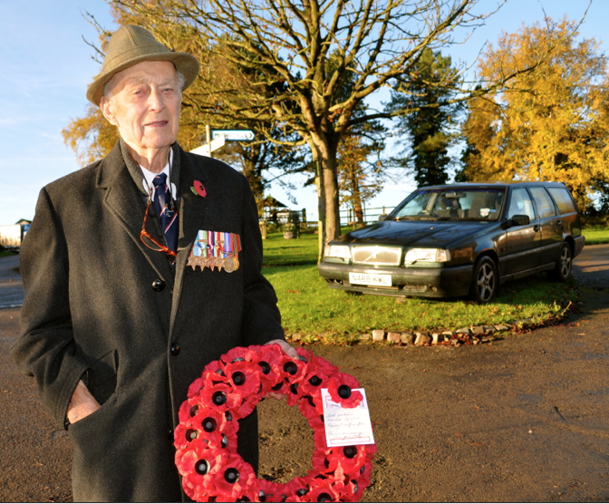
We would welcome offers to help with the planting, please contact Cllr Jan Burgess, if you would like to help with this project. The Parish Council as customary donated the memorial poppy wreath and it is with some poignancy that Bill Spencer laid the wreath for the last time on behalf of the community Bill will be sadly missed. To find out more about our war heroes visit www.shotteswellvillage.co.uk
Picture of Bill by kind permission of the Spencer family.

Broadband in South Warwickshire
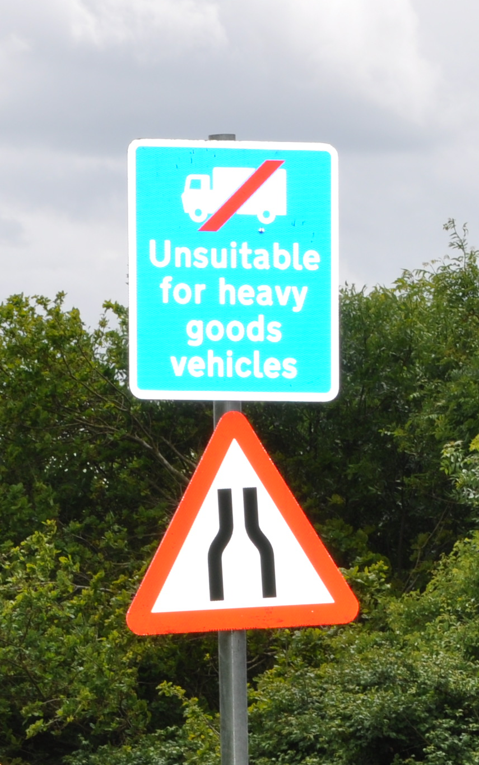
We always knew that the funding would be insufficient to cover the whole of the area and that is simply because some places are more challenging. This may be because of geography - perhaps they are more remote from existing infrastructure because of the local topography or because of other issues.
The network is being rolled out using fibre because that is the most future-proof technology that will enable faster speeds (such as those required for the EU 2020 targets) to be achieved. Wireless or other technologies are not currently able to do this. The current national target is that the final 10% should receive a minimum of 2Mbps, although in practice this may be anything up to 23.99Mp - at 24Mbps it becomes superfast
Each community is currently served by a green cabinet, which serves as a distribution point for the copper which runs from the exchange and is then split to serve each property. The programme involves the installation of an additional cabinet, which is fed by a fibre connection from the exchange, and then links in to the existing green cabinet so that the final distribution is by copper. As broadband signals degrade over lengths of copper the current distance from the cabinet over which superfast broadband can currently be achieved is around 1km. However, this will be dependent on a number of factors including the quality of the existing copper connection and conditions at the property itself. The positioning of the new cabinet is crucial, as it has to be near the existing cabinet, but unlike the existing cabinet also requires a power supply. There are also highways and other issues to be considered.
Some of the existing green cabinets are over 1km from the local communities, for instance where a cabinet serves a number of villages, and so will not be able to achieve superfast speeds using the technology that is funded under the current programme.
The ultimate aim is to achieve the 2020 EU targets with each property receiving a minimum of 30Mbps (which is higher than the current highest target).
The Government has announced additional funds of £3.68m to take superfast broadband coverage up to 95% (our current project will achieve 91%), however this will have to be match funded. In the current economic climate it is not easy to see where the required match funding will come from, but recently a submission through the Coventry and Warwickshire Local Enterprise Partnership European Structural Investment Funds Strategy for a total of £7.85m. Unfortunately the timing of any allocation from EU funds is unlikely to meet the deadline by which they must apply for the Government funding
Warwickshire broadband are also looking at procurement options for the additional coverage. The areas to be covered by the additional funding will not be known until after the procurement is complete.

HGV sign on Mollington Road, motorway junction

We are disappointed that despite securing permission from the Highways to erect the unsuitable for HGV sign to prevent damage being sustained to verges and property that the sign was removed unnecessarily. The HGV lorries are largely responsible for the condition of the Mollington Road verges and consequently the mud on the road. The council will continue to lobby to have this sign restored to protect the village from sustaining further damage.
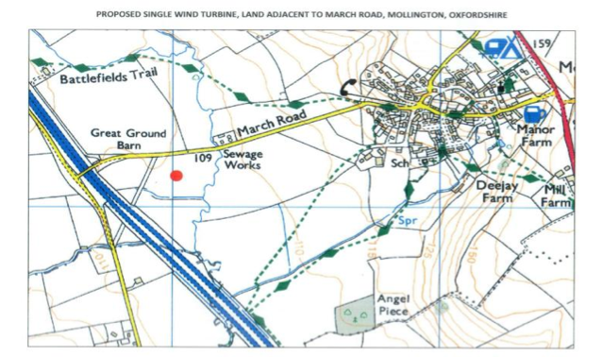
Wind Turbine

The application to build a 77metre high wind turbine, near the motorway bridge leading to Mollington has been lodged with Cherwell District Council. A letter explaining this proposal has been circulated to the village. Anyone who would still like to make a response can do so either on line or by post the application reference is 14/00011/F. Comments lodged can be viewed on the Cherwell Web Site. The Parish Council has responded with an objection to this application and is joined by no less than seven other Parish Councils, our Ward Member Cllr Jackson, MP Jeremy Wright and many residents from this and surrounding parishes.

Donations: A contribution of £500 is being made to the Village Hall Committee to help them towards repairs to the kitchen window, which has rotted and needs replacing.

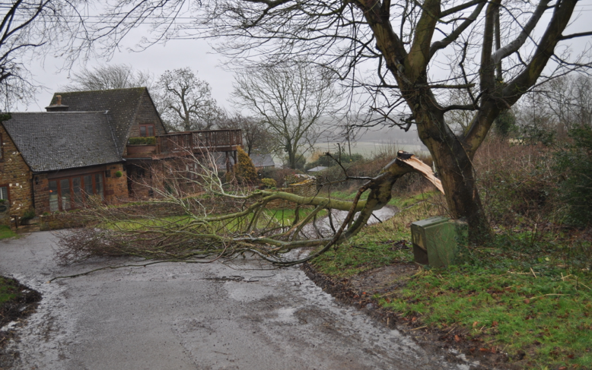
A donation of £500 is being made to the church to help them towards repairs. More work is required due to the churchyard wall falling down in the recent storms.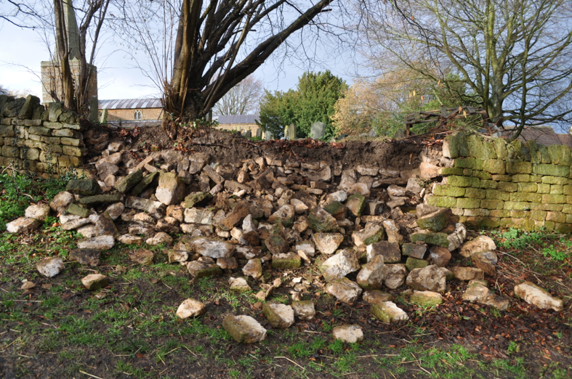
Church wall, following the storms Further storm damage along Church Lane

Houblon £50 bank note withdrawal


The £50 bank note depicting Houblon is being withdrawn from circulation from 30th April 2014. For several months after most banks and building societies will continue to accept Houblon notes although they are not obliged to. Barclays, Nat West, RBS, Ulster Bank and the Post Office, have agreed to accept the Houblon notes for customers and non-customers, up to the value of £200, at their branch counters until the 30th October 2014. The Bank of England will exchange old series bank notes for all time. Details on where and how to exchange can be found on the Bank of England website:
www.bankofengland.co.uk/banknotes/Pages/abour/exchanges.aspx
The newer £50 note featuring Matthew Boulton and James Watt, in circulation since 2011, remains as legal tender.

Children’s Playing Field

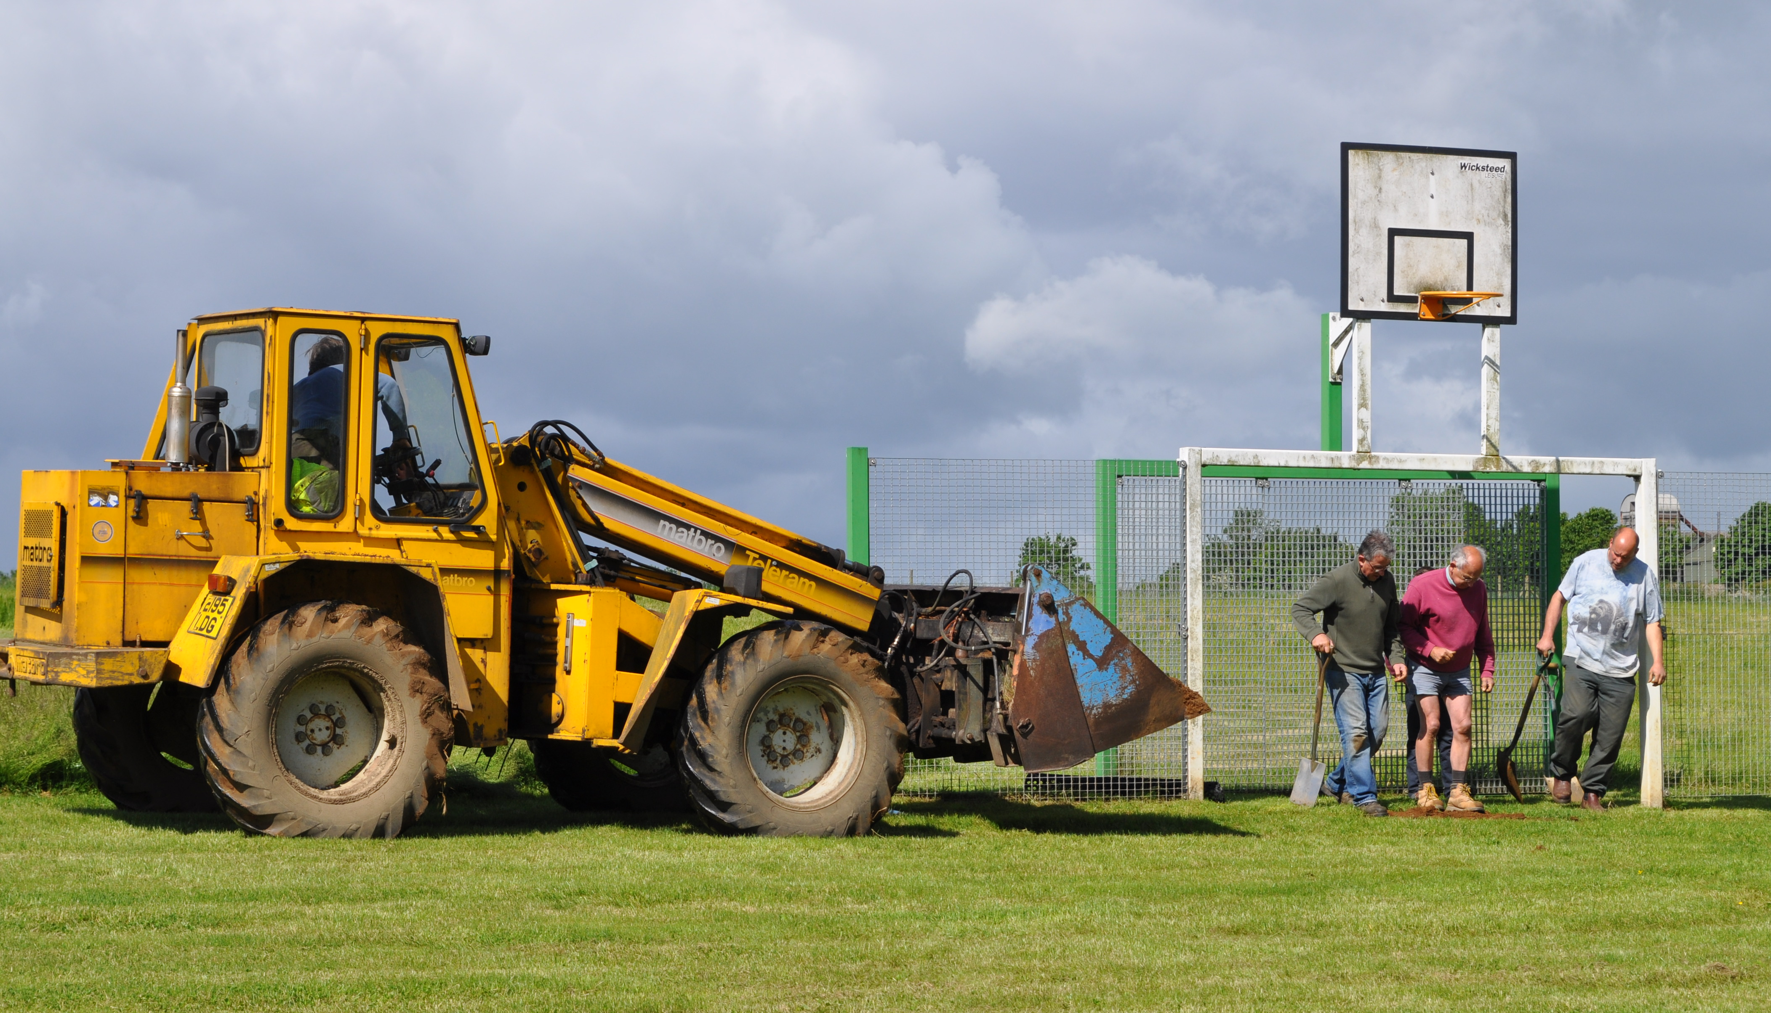
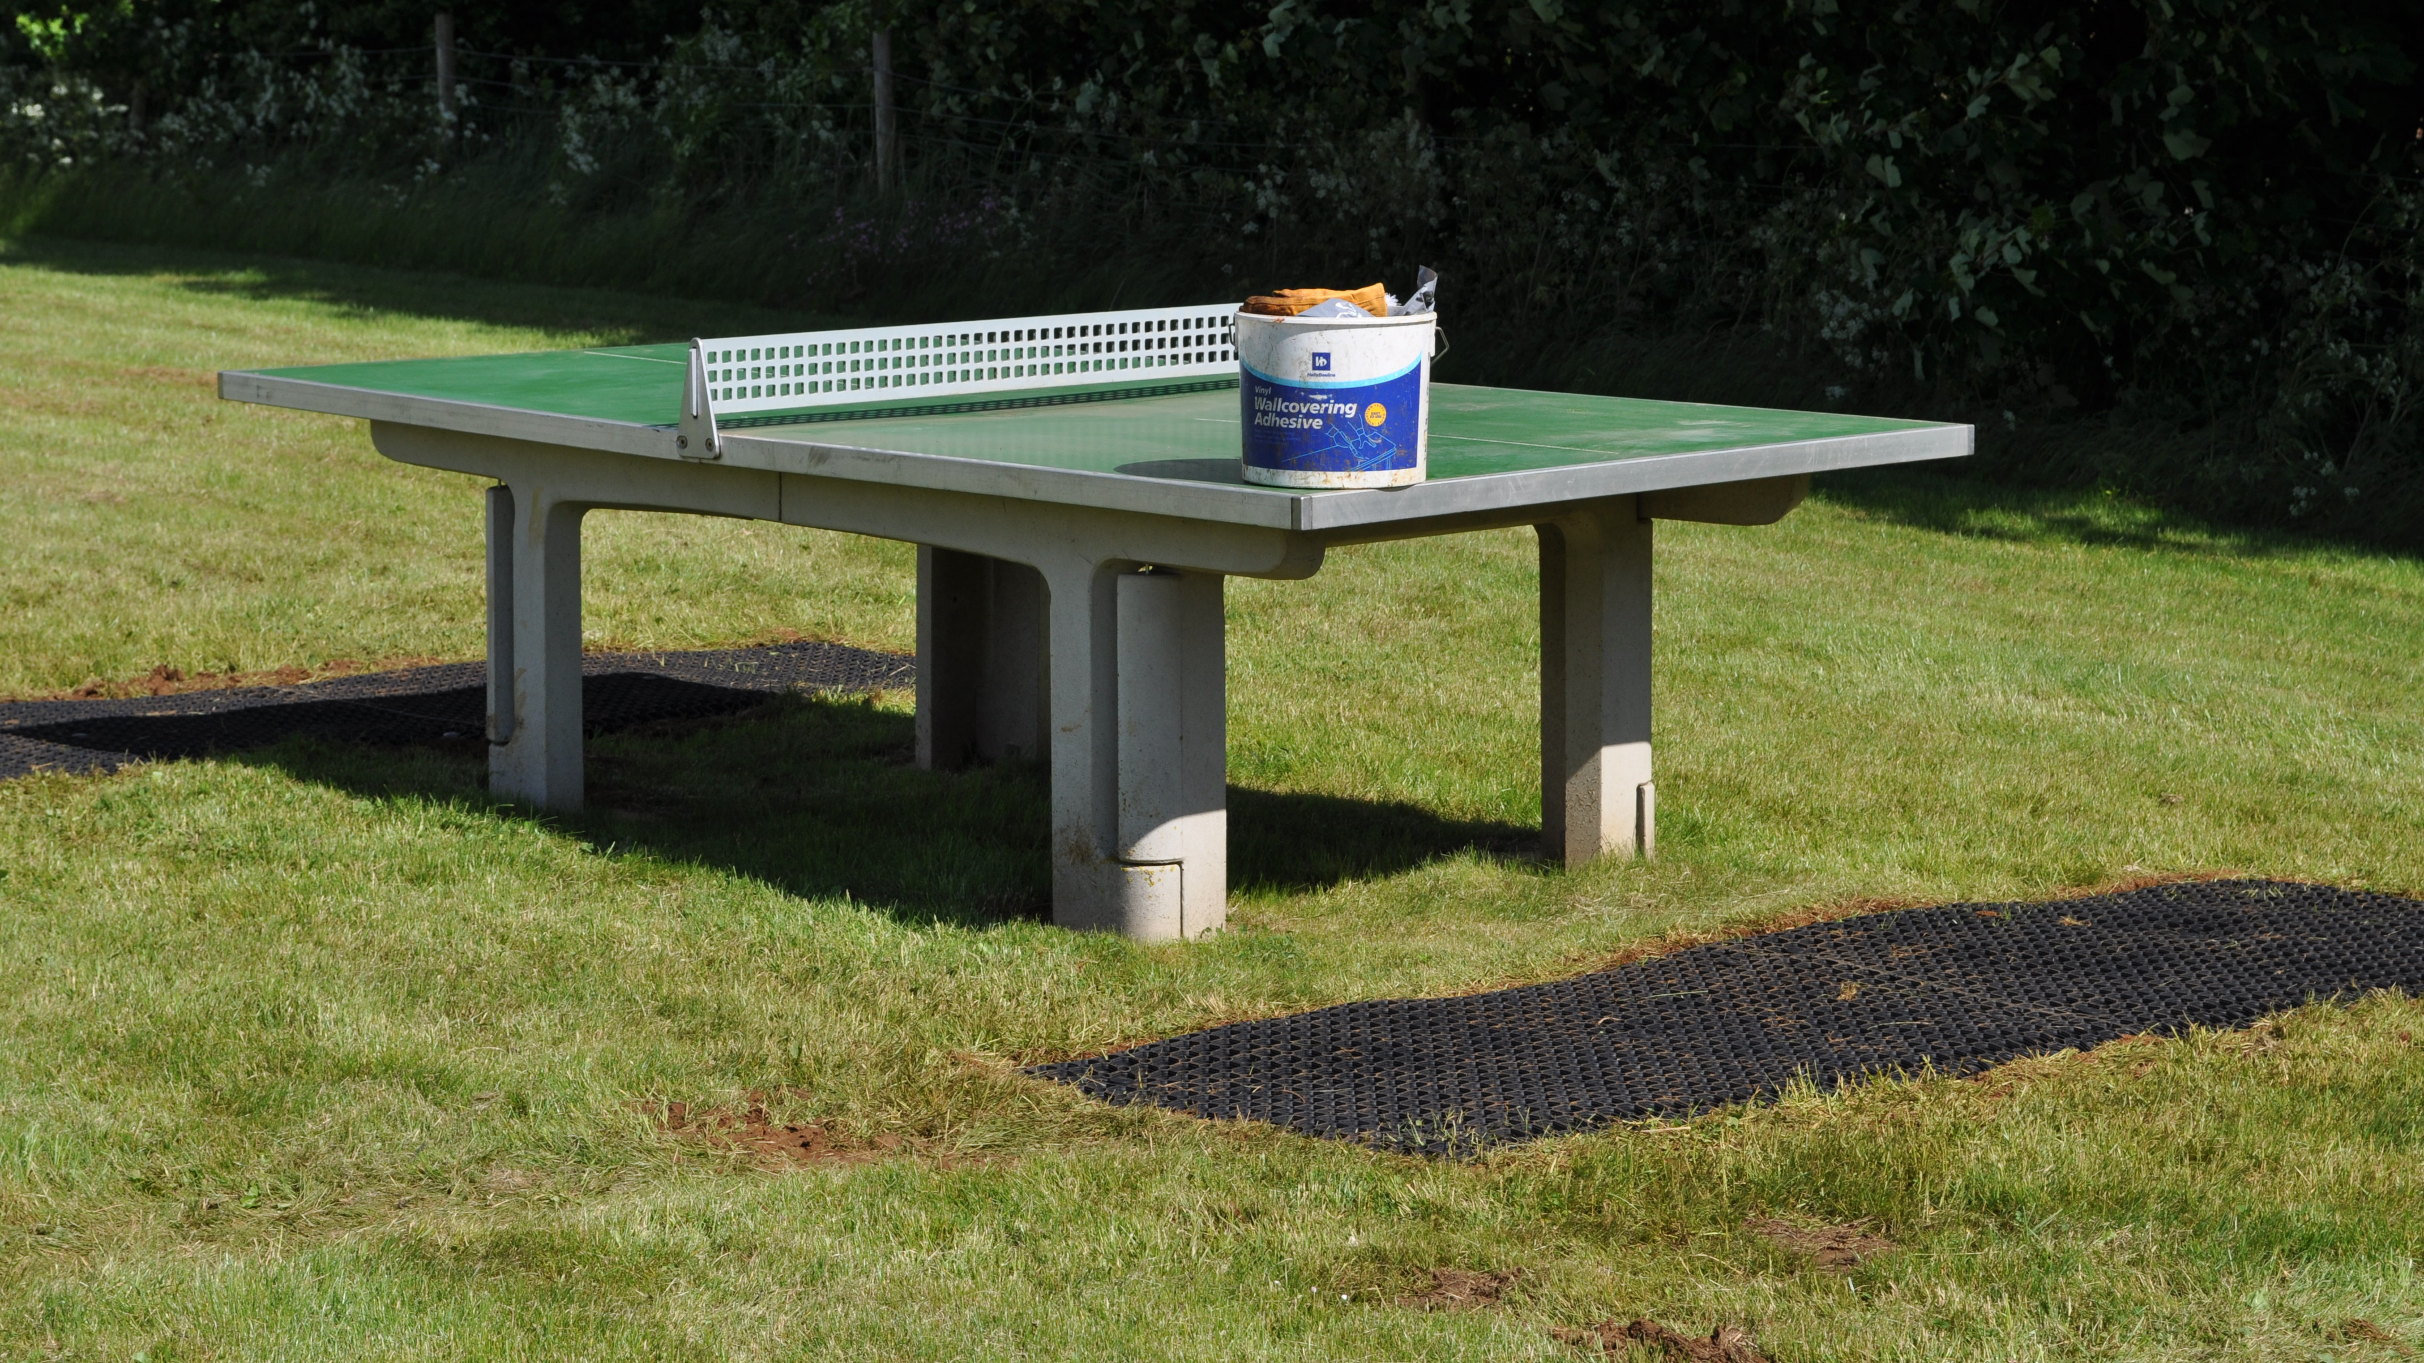
This facility appears to have proven to be extremely popular and if anything is increasing in its usage. Many fundraising actives such as the village fete, children’s parties and charitable fundraising (which often leads to hiring the hall for toilet facilities, bringing in extra revenue for the hall) are held there and children and their families continue to enjoy the equipment. We are reliably informed that our field is considered to be the jewel in the crown in the Stratford area as far as playing fields go. The Parish Council recently further improved the field and as such was commended for their initiative by the RoSPA inspector. The Parish Council, installed safety surfacing to prevent erosion in the goalmouth and in front of the table tennis table. We will shortly be making further improvements to try to deter bird fouling and intend to decorate the tree house, later this year. My thanks to the work party, consisting of all Parish Councillors and to a resident for his invaluable help.
Safety surfacing being laid in the goal mouth Safety surfacing laid by the tennis table
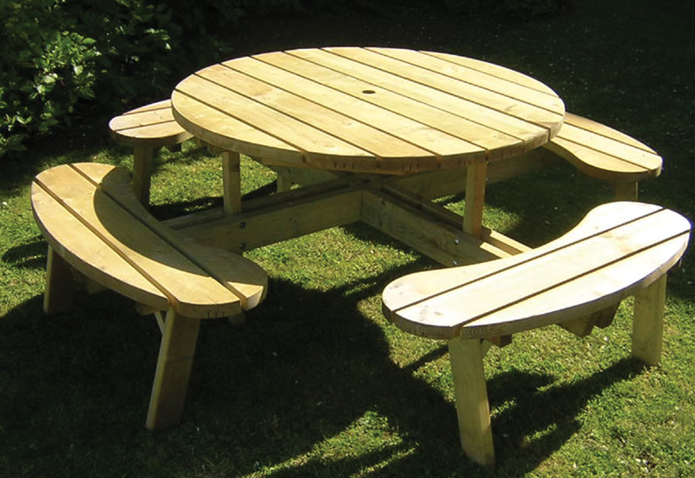
The Jubilee Committee and the Parish Council paid for the new picnic bench, which is providing additional seating in the Children’s Playing Field (pictured left). We appreciate the Jubilee Committee’s contribution towards the purchase.
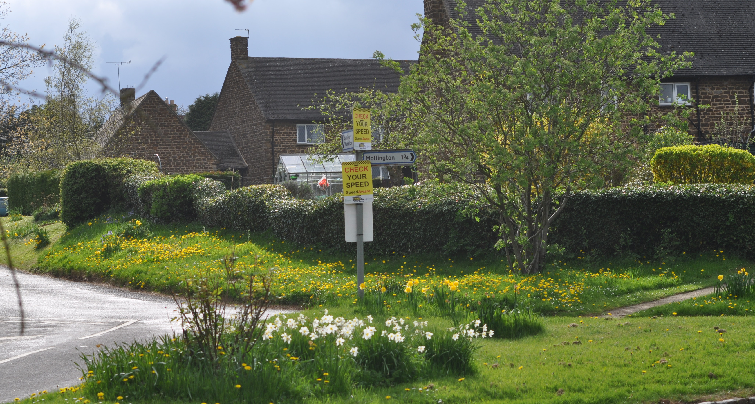
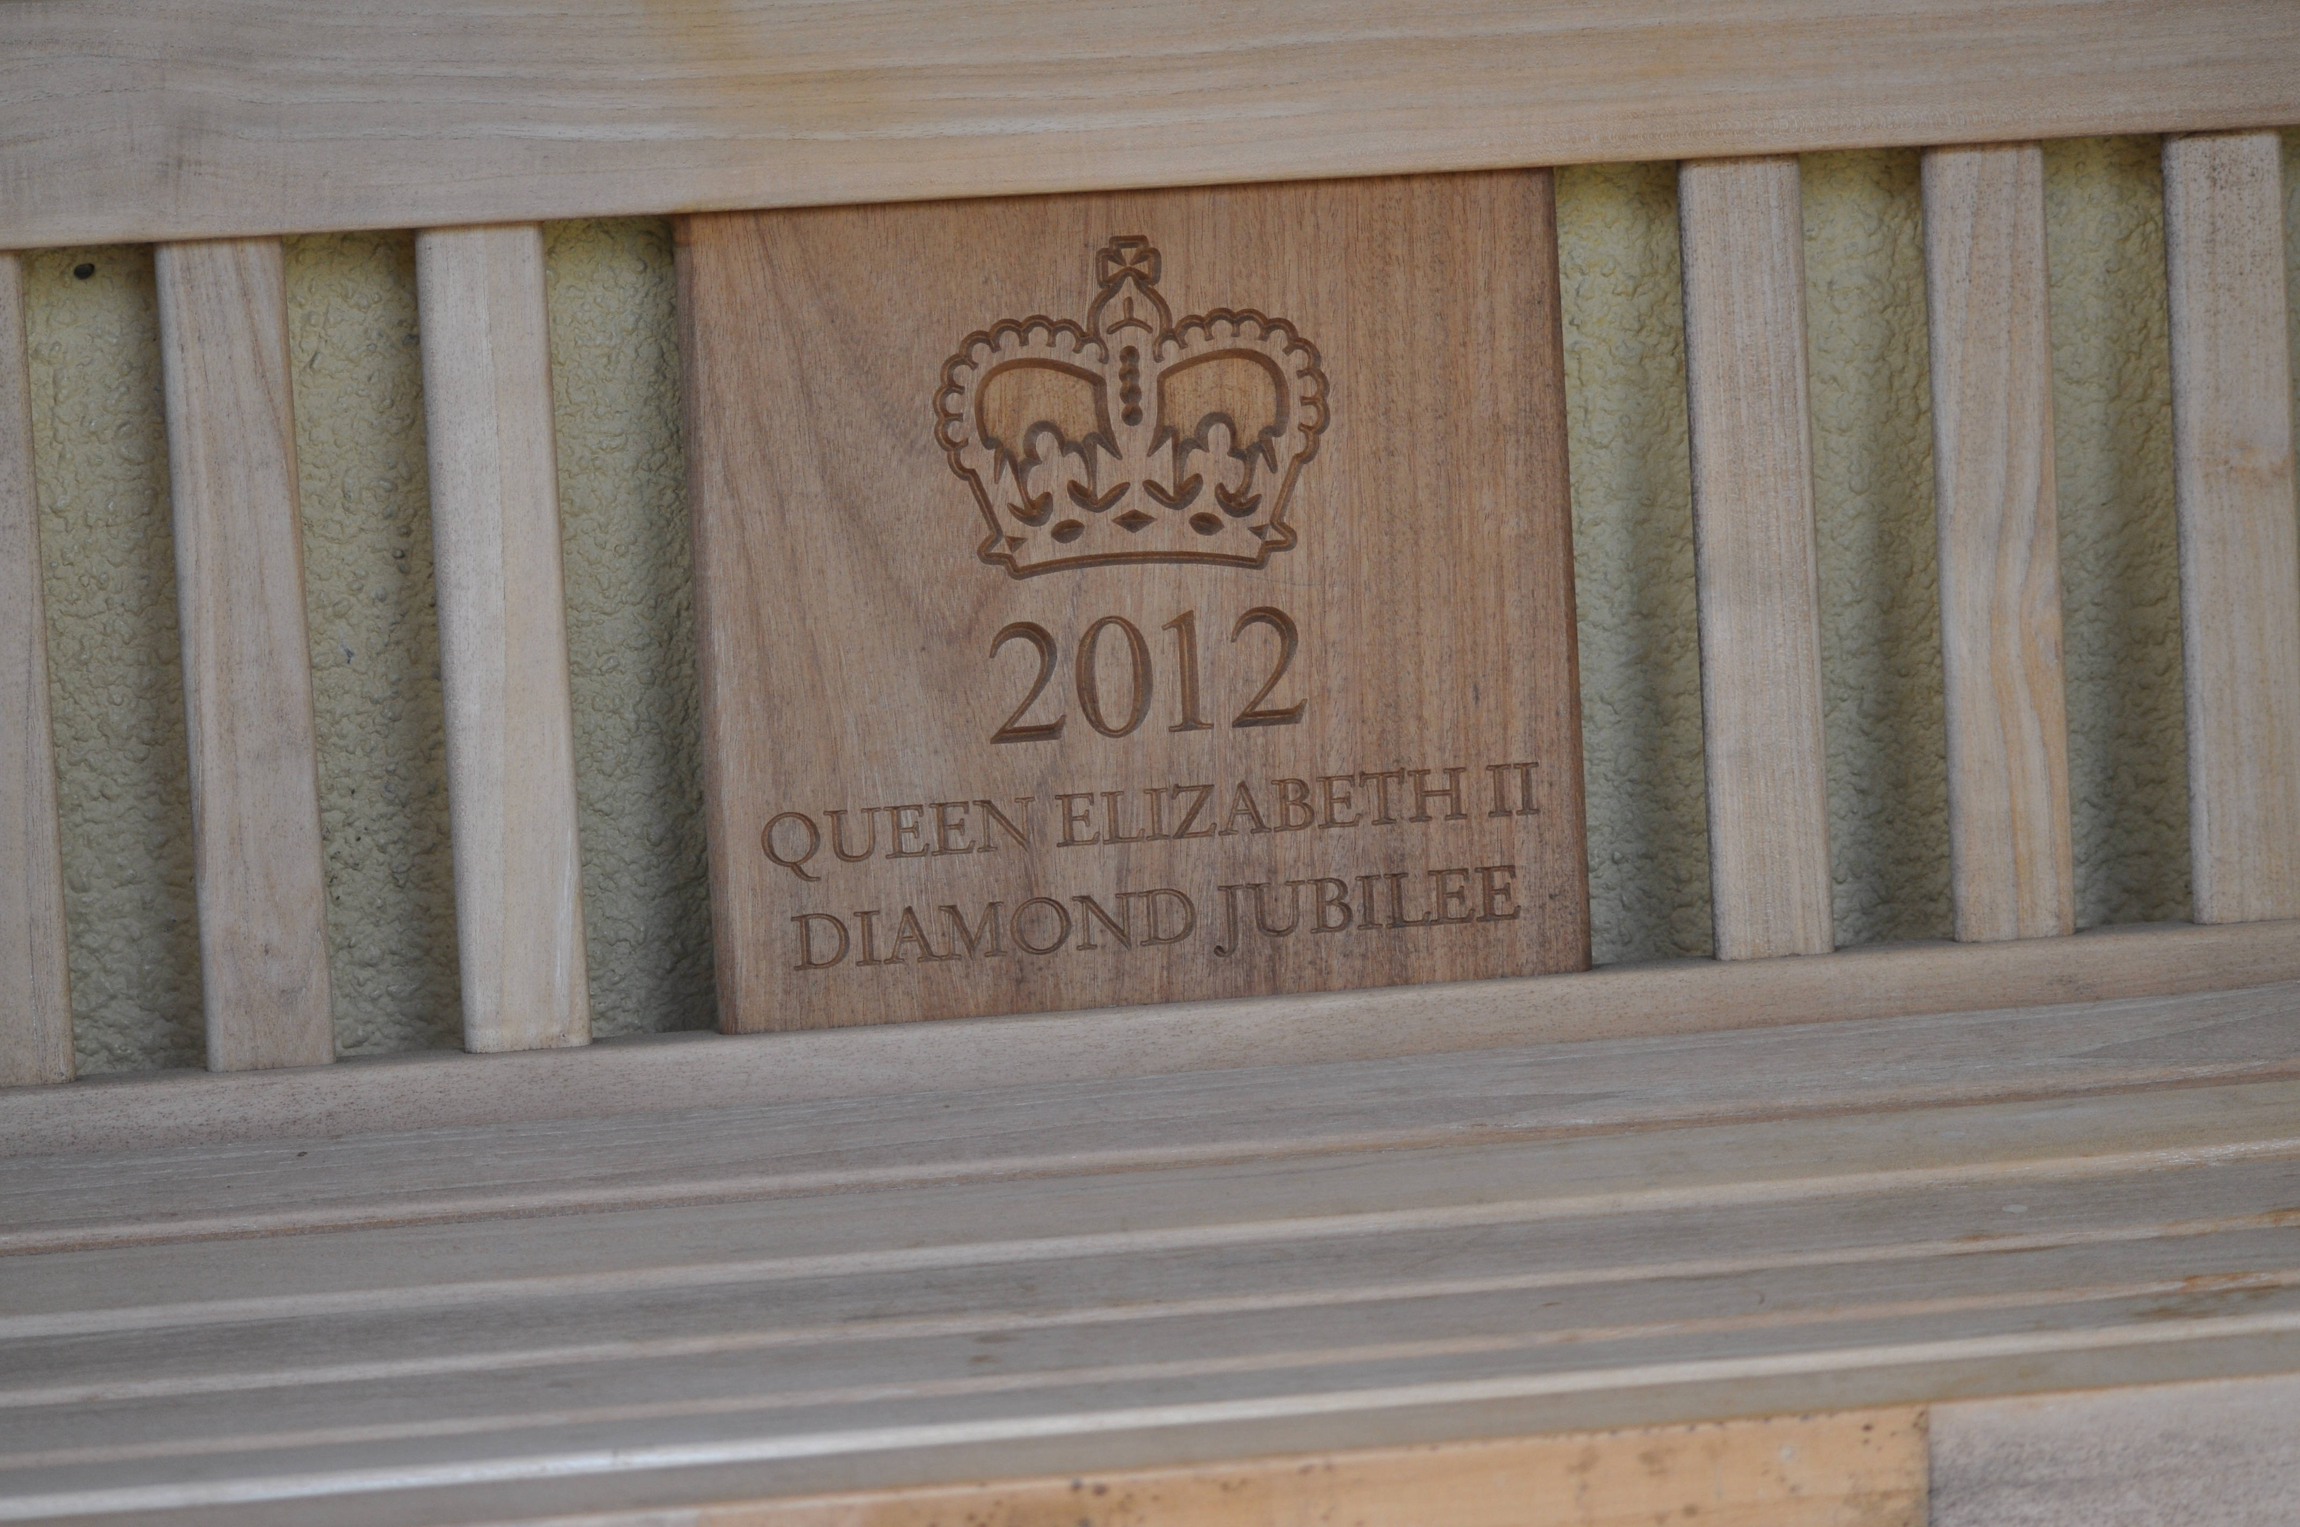
Following a request for a seat in the bus shelter to enable people waiting for the service bus, school buses and the library van, somewhere to rest, a seat was provided (pic right). Feedback has been very positive.

The Parish Council instigated a speed awareness campaign last summer to encourage drivers to drive more considerately through the parish.
However, past experience has shown that registration plate numbers passed to the police, for anyone driving recklessly appears to be the most effective way of dealing with any issues. Please let the Parish Council know of any problems.

Finally, we were very disappointed with the standard of grass cutting of the highway verges last season, these complaints were conveyed to Stratford District Council, we will continue to monitor the service, although some improvement was noticed as the season progressed.
We would like to thank all residents in their various capacities for contributing towards helping the Parish Council care for Shotteswell.
Les Faulkner Chairman

